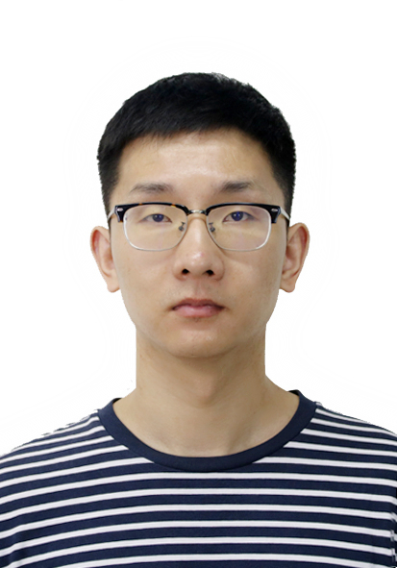

DEGREE
BASIC INFORMATION
Name：Jiangang Wen
Location：Hangzhou
Email：wjg1214@mail.zjgsu.edu.cn

PERSONAL RESUME
Birthday：1989.12
TEL：13738028546
Jun. 2019-Present：《Digital Signal Processing》,《Modern Communication Technology》,《EDA Technology》,《Analog Electronics Technology Experiment》,《IoT Architecture》. School of Information and Electronic Engineering (Sussex Artificial Intelligence Institute), Zhejiang Gongshang University.

- B.S.: Electronic information engineering, Zhejiang University of Technology
- Ph.D: Control Science and Engineering, Zhejiang University of Technology
- Research Direction：
Next generation wireless communication technology, Filtered multi-carrier, Digital filter, Wireless positioning.
- Publications：
- Wen J G, Zhou L J, Hua J Y, Sheng B, Wang A D. Design of nonlinear phase prototype filter based on coefficients symmetry for UFMC communication system[J]. Digital Signal Processing. 2023, 138: 104053.
- 闻建刚, 岳洋洋, 华惊宇, 倪郑威, 徐志江, 余绪涛. NLOS状态信息辅助协方差矩阵修正的无线网络定位方法[J]. 传感技术学报. 2022, 35(11): 1561-1567.
- Wen J G, Hua J Y, Zhang Y, Li F, Wang D M. The nonlinear-phase design of FBMC prototype filter based on filter coefficient symmetry characteristic[J]. Wireless Networks, 2020, 26(3): 1969-1980.
- 闻建刚, 华惊宇, 徐志江, 李枫, 陈浩. FBMC系统中的SR-NYQ原型滤波器设计[J]. 中国科学：信息科学, 2019, 49(7): 886-899.
- Wen J G, Hua J Y, Li S N, Zhou K, Wang D M. Interference-driven designs of nonlinear-phase FIR filter with application in FBMC system[J]. China Communications, 2016, 13(12): 15-24.
- Achievements：
- First-author papers：11, including 5 SCI papers, 4 EI papers, and 2 Chinese core papers.
- Non-first-author papers: 16, including 10 SCI papers, 3 EI papers, and 1 Chinese core paper.
- Host 1 Zhejiang provincial natural science foundation project, participate 3 national natural science foundation projects and 2 Zhejiang provincial natural science foundation projects.
- Authorized patents: 4.

XXXXX银行 银行柜员
工作内容：
- 负责办理客户账户开立、收付现金、转账、回单打印等柜面对外业务；
- 负责个人日终轧帐相关业务，按要求整理业务传票及编制相关报表；
- 按负责掌管现金箱包、保险柜等的钥匙，履行管库职责。

RESEARCH&PUBLICATIONS
TEACHING

